Security guard with camera and night vision light

The advent of new high-speed technology and the growing computer capacity provided realistic opportunity for new robot controls and realization of new methods of control theory. This technical improvement together with the need for high performance robots created faster, more accurate and more intelligent robots using new robots control devices, new drives and advanced control algorithms.

The main aim of this project is controlling the robot direction and view the video transmitted from camera mounted on robot and this robot has automatic lighting system to provide light at dark places automatically. This project describes a new economical solution of robot control systems. The presented robot control system can be used for different sophisticated robot applications. The system can be viewed as two different modules- transmitter and receiver sections. The transmitter module consists of PC or TV, 433 MHz RF transmitter with HT12E 4 bit encoder and camera receiver to receive the data from camera which is mounted on robot. We have to choose the direction of the remote by pressing respective switches which are connected to HT12E.The data presented on HT12 is being transmitted to RF receiver through RF transmitter.

On the other hand, the receiver module receives the transmitted data and passes the data to the microcontroller. Thus, the microcontroller changes the direction of the robot according to the specified command. Since the microcontroller cannot drive the motors (used for robot) directly, L293D is used as a driver to provide the sufficient current required for the motors. The motors receive the input from the microcontroller and the required current from the power supply through L293D.

The robot will be equipped with camera and low power high illuminated white LED as night vision light and the darkness will be identified using light sensor. The output of the camera is given to the television where the entire view of the predefined location can be viewed all the time.

SOFTWARE AND HARDWARE TOOLS:
Software Tools:
- Keil compiler
- Orcad.
- Proload

Hardware Tools:
- Microcontroller AT89S52.
- PC or TV
- Motors and driver circuit
- RF module with HT12e and HT12d
- Camera and receiver
- White LED
- LDR light sensor

Block diagram
Transmitter side

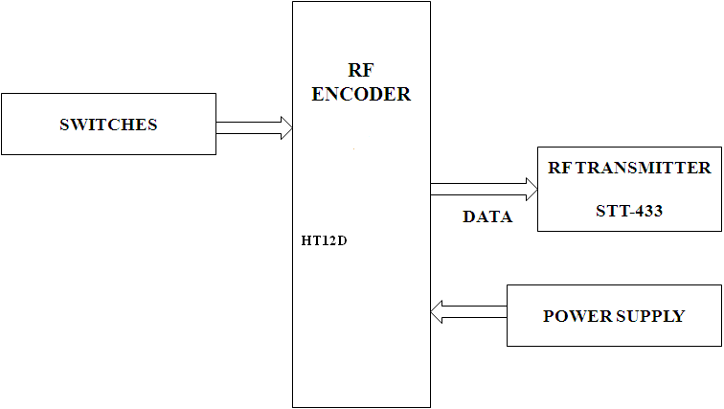

PC or TV
Camera audio video receiver

Receiver section
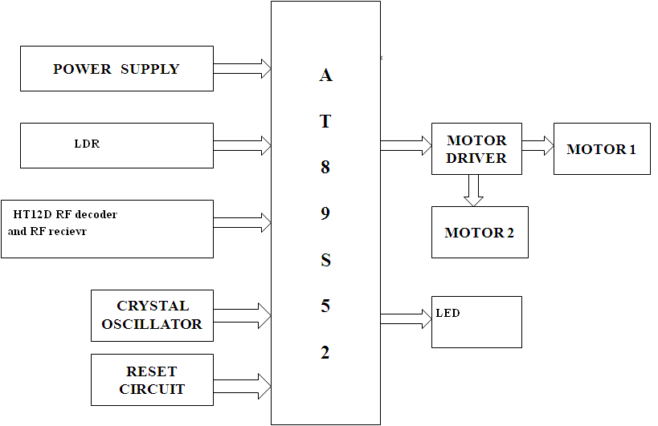

Camera image transmitter
Camera mounted on Robot

